PROMETHEUS was the Titan god of forethought and crafty counsel who was entrusted with the task of molding mankind out of clay. His attempts to better the lives of his creation brought him into direct conflict with Zeus. Firstly he tricked the gods out of the best portion of the sacrificial feast, acquiring the meat for the feasting of man. Then, when Zeus withheld fire, he stole it from heaven and delivered it to mortal kind hidden inside a fennel-stalk.
As punishment for these rebellious acts, Zeus ordered the creation of Pandora (the first woman) as a means to deliver misfortune into the house of man, or as a way to cheat mankind of the company of the good spirits. Prometheus meanwhile, was arrested and bound to a stake on Mount Kaukasos where an eagle was set to feed upon his ever-regenerating liver (or, some say, heart). Generations later the great hero Hercules came along and released the old Titan from his torture.
http://www.theoi.com/
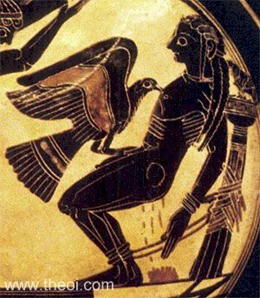
An ETERNAL FLAME is a memorial consisting of a perpetually burning flame.
Eternal flame Memorial in Sarajevo, Bosnia (Southeastern Europe)
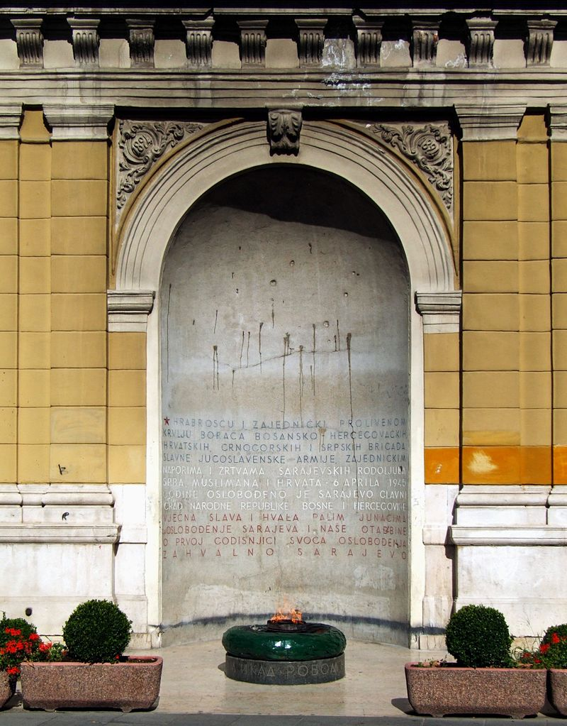
"Vječna vatra, Sarajevo (by Pudelek)" by Pudelek (Marcin Szala) - Own work. Licensed under CC BY-SA 3.0 via Commons
The OLYMPIC FLAME is a symbol of the Olympic Games. Commemorating the theft of fire from the Greek god Zeus by Prometheus, its origins lie in ancient Greece, where a fire was kept burning throughout the celebration of the ancient Olympics. The fire was introduced at the 1928 Summer Olympics in Amsterdam, and it has been part of the modern Olympic Games ever since.
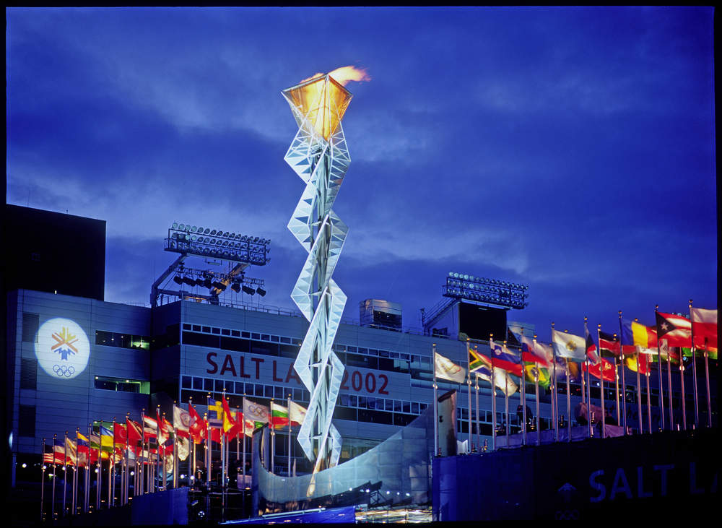

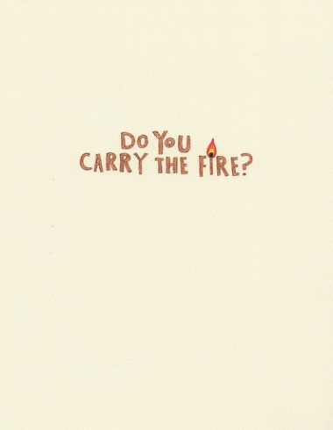 The Road
You have to carry the fire.
I don't know how to.
Yes, you do.
Is the fire real? The fire?
Yes it is.
Where is it? I don't know where it is.
Yes you do. It's inside you. It always was there. I can see it.

