Cormac McCarthy's The Road May Have the Scariest Passage in All of Literature
Benjamin Percy, author of Red Moon, makes the case.
Joe Fassler May 14 2013, 11:44 AM ET * Theatlantic.com

More
0
inShare
Email
Print
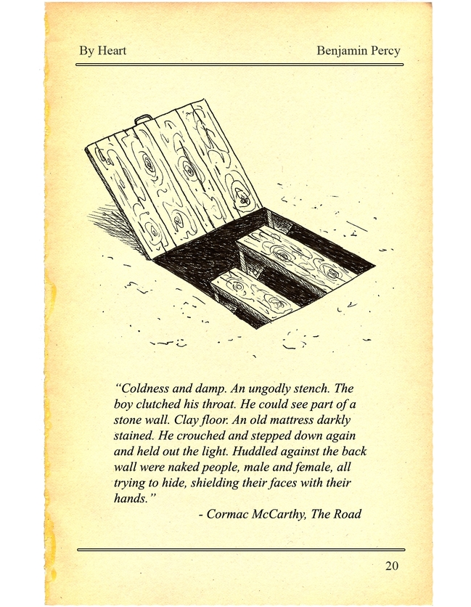
Doug McLean
By Heart is a series in which authors share and discuss their all-time favorite passages in literature.
Interview Introduction
Masters of the horror genre know that monsters are scariest before they're seen.
This is why the makers of Jaws, according to co-writer Carl Gottlieb, kept their shark unglimpsed so long. Their model was The Thing from Another World (1951), which hid its nightmare creature until the end. Before them, we had Melville's distant whale and Verne's squid shrouded in its weird sea. Poe took the dread of temporary blindness to the extreme—the monster of the "Pit and the Pendulum" is a world plunged into total darkness.
Benjamin Percy, whose new novel Red Moon updates the werewolf mythos for our era, loves the way suspense ratchets up before something terrible is revealed. When I asked him to choose a favorite passage from literature, he chose a section from Cormac McCarthy's The Road that has haunted him for years. It's the only instance Percy can think when what's finally revealed is, in fact, far scarier than anything he could have imagined.
In addition to Red Moon, Benjamin Percy is author of The Wilding and two acclaimed story collections. His story "Refresh, Refresh" was selected for Best American Short Stories 2006. His nonfiction regularly appears in venues like GQ, Outside, and Esquire, where he's a contributing editor. He spoke to Joe Fassler by phone.

Benjamin Percy: I picked up Blood Meridian as my first introduction to McCarthy. I remember, at that moment when there's thunder on the horizon and a cloud of dusk and the horde of Apaches dressed in the blood-stained wedding garb as they thunder towards Glanton and his men, being completely overwhelmed by both the language and the horror and the beauty of the situation. I actually set the book aside after I read that passage and felt as though I'd been rewired aesthetically.
McCarthy's is an elemental voice. In his voice I hear stone shifting, glaciers cracking open, trees moaning in the wind. The ancient cadences of his prose take on an almost otherworldly quality, a quality that transports you. I'm constantly in awe of the language and recognizing how he's putting together his sentences so exquisitely. As many have pointed out before me, he's unafraid to stare into the abyss. He's peering into the darkest corners of human existence, using a lamp with blood.
I've read The Road several times now, but the first time I read it was soon after my son was born. I was especially emotionally vulnerable in that moment because he was having some issues with his breathing: He ended up getting a severe case of croup that closed his throat. He was transported to the hospital by ambulance and was in the ICU for three days. They pricked him full of steroids and put him in an oxygen mask. I've never felt more protective, or helpless, or scraped out emotionally than I did then.
Reading this book around that time put me in a mindset that made me particularly vulnerable to the subject matter. The Road is ultimately about a father sacrificing everything for his son—keeping on and surviving despite a nightmare landscape, and only for his son's sake. I felt plugged into that current in a way that I don't know I would have if not a father.
The most terrifying moment in any horror story is when a noise is heard—a noise behind a closet door; a noise heard in an attic, or the basement; a noise heard in a thicket of bushes; a noise heard deep in a cave—and a person pursues the sound. We always want to yell out: Don't go there. It's that moment of suspense, the second before the bogeyman is revealed, that is the most gripping. After the door opens, after we shine a flashlight on whatever awaits, the audience might laugh or scream but ultimately they feel relief. Because whatever is provided by the author or filmmaker is never as bad as what we imagine ourselves.
In this particular passage, as soon as the father spots a house on the hill, we know something terrible waits inside. It takes a long time for him to approach the house, to explore its many rooms, and finally descend into the basement.
He started down the rough wooden steps. He ducked his head and then flicked the lighter and swung the flame out over the darkness like an offering. Coldness and damp. An ungodly stench. He could see part of a stone wall. Clay floor. An old mattress darkly stained. He crouched and stepped down again and held out the light.
The whole time we're yelling: Don't go in there. But he does, of course.
Huddled against the back wall were naked people, male and female, all trying to hide, shielding their faces with their hands. On the mattress lay a man with his legs gone to the hip and the stumps of them blackened and burnt. The smell was hideous.
Jesus, he whispered.
Then one by one they turned and blinked in the pitiful light. Help us, they whispered. Please help us.
And maybe this is the only time this has ever happened to me—but what is revealed is even more terrifying that what I could have imagined. Humans are harvesting each other in order to survive. These pale, chewed-up creatures emerge from the dark and rattle their chains and moan and reach for the father. We're afraid of them, but we're afraid more of what might await the father upstairs—the people responsible for this.
I tried for a similar effect in the opening chapter of my new novel, Red Moon. You see a man moving through an airport, the muscles in his jaw flexing, his gaze trained on some middle distance. He's sweating heavily. He is relieved to make it through security. He's staring at the ghost of his reflection in the window as he studies the tarmac. He is biting back at any attempt at conversation his seatmates might have when finally on the plane. And when he stands up and retreats to the restroom when the flight is at 30,000 feet, you know something terrible is going it happen. It's been a long, slow spinning fuse leading towards a detonation. It's the same device McCarthy's using as The Road's father explores the house and finally heads down to the basement: a long period of withholding as long as we can, suspense-deepening, stakes-raising, until finally what's hidden in the darkness is revealed.
It's the same reason we climb onto a roller coaster. It's the same reason we climb a cliff and put our foot out over the open air and pull back. We're daring the nightmare. You never feel more alive than in that moment. It's a reminder of our mortality. If you look at the horror novel, or the horror movie, it's a way of safely dealing with that spike of adrenaline.
I'm still haunted by that passage. No matter how many times I read the book, it still seems to affect me. It grabs you by the throat and drags you down the rabbit hole. Our world dissolves, his world takes over. That's a major accomplishment—when you make flesh and blood and wood and stone out of ink and paper.
Though McCarthy's not afraid to stare into the abyss, he seems to also carefully consider his use of violence. When I'm reading someone like Chuck Palahniuk, I often feel he's titillated by a kind of gorenography. He's writing violence in a way that feels excessive and part of some carnival sideshow meant to make people slap their knees and guffaw horribly. When I look at The Road, or a book like Blood Meridian, McCarthy describes every terrible thing that a mind could conjure. But he'll also pull back. He'll allow some violence to take place off stage, because he knows unseen acts can be as brutal and affecting as violence that's shown—perhaps more so.
I feel that violence needs to be earned somehow—or it needs to earn out. You need to pipe the oxygen in before lighting the flame—or, in the wake of some violent act, there needs to be repercussions: a period in which the characters suffer and soak up what has occurred. Making it part of the causal structure and making it emotionally resonant, too. I would hope that any narrative that wrestles with this sort of thing is meant to horrify, and not excite. To discourage, instead of encourage, violence. And that's the problem with movies like Saw and Hostel: They make a bloodbath into a kind of joyous exercise.
I've been practicing for these kind of scares my whole life. I grew up on genre: Westerns, sci-fi, fantasy novels, mysteries and spy thrillers—but especially on horror. Horror's always gripped me in its bony fist. So I read everything by Shirley Jackson, and Anne Rice, and Stephen King, and Peter Straub and Robert Aikman, John Saul, and Dean Koontz, and H. P. Lovecraft, and Poe. There's something about me that's drawn to darkness and to the theater of fear. I can't quite put a finger on why that is—it's the same reason some people like romance stories while others like action movies. But my greatest pleasure growing up was terrifying my sister by leaping out of closets with my hands made into claws, or scratching at her bedroom window. She slept with the light on until she was 27. I guess that was training ground for the novelist I've become.
I've become so attuned to craft that it's sometimes difficult for me to get lost in a story. When I grew up reading, the only thing that concerned me was the question of what happens next—and the pages turned so fast they made a breeze across my face. The Road, for the first time in a very long time, owned me emotionally in that same fashion. I was able to turn off my craft radar and be swept away. I felt true terror. The kind of terror that used it make me, when I was a kid, wrap the sheets around my face and breathe through a little blowhole in fear of the shadow that seemed at the edges of my room. Cormac McCarthy, that dark sorcerer, makes me feel that way again.

